2.5 I can understand the structure of and processes within our atmosphere.
What is Meteorology?
The study of ________________________________________________________

How does Weather and Climate differ?
Weather is constantly changing and it refers to the state of the __________________________________________________________________
Climate is based on ______________________________________ that have been collected over ____________________________ to help describe a place or region
Atmosphere
Purpose: provides a suitable __________________________________________________ for organisms as it absorbs only small amounts of UV rays
Greenhouse Gas Effect:

Main Components | Layers | Description
________________– 78%  (Greenhouse Gas) | Thermosphere (hottest) | farthest from Earth  Temperature ________________with height
________________ – 21%  (Greenhouse Gas) | Mesosphere | Temperature _______________ with height
CO2 < 1%  (Greenhouse Gas) | Stratosphere | Temperature remains ___________________, then gradually starts to __________________  contains ‘good’ ozone
Argon < 1% | Troposphere  (coldest) | closest to Earth, contains the ‘bad’ ozone due to air pollution -WEATHER

Ozone
- Ozone is a form of oxygen that combines __________________ into each molecule (O₃)
- Ozone filters and absorbs harmful _______________________________ by the sun

Water in Atmosphere
- Precipitation is any ______________________________________ that falls from a cloud.
- When it comes to understanding atmospheric processes, water vapor is the most important gas in the atmosphere

Land and Water Temperatures
- Land ______________________________________ during higher temperatures than water
- Water – takes ______________________________________ to heat up and cool down

Coastal Climates
The oceans heat up _________________but retain the heat for a __________ period of time.
Sea Breezes blow _____________bringing rain and ___________the land in the summer.

In the winter, the coastal climates are warmer and generally ________________

Cloud Cover
Daylight Cloud Cover --- Temperatures are lower than on a clear day
Nighttime Cloud Cover ---Temperatures are higher than on a clear night

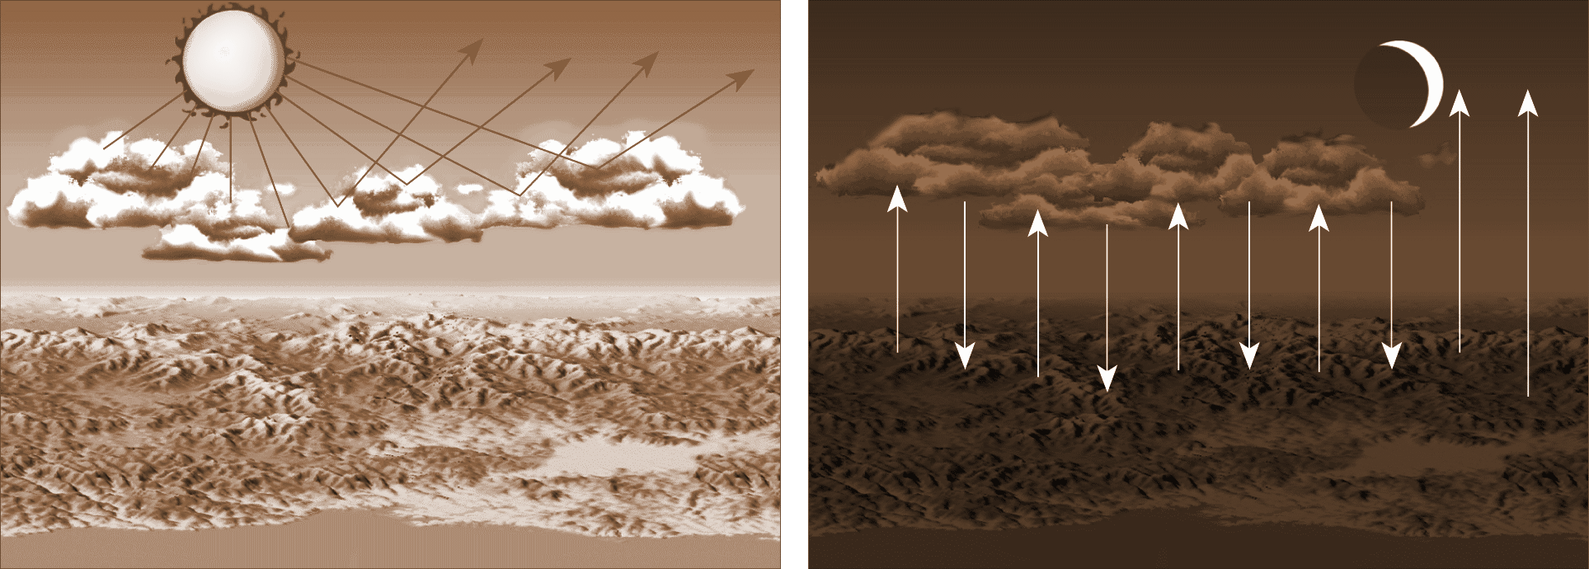

Isotherms - a line on a map connecting points having the ______________________________ _____________________________________ at a given time or on average over a given period

Ways Heat can be Transferred
- Conduction: objects touching
- Convection: mass movement or ____________________________ within a substance
- Radiation: through rays of heat

Humidity
amount of water vapor in air

Relative Humidity
Ratio of the air’s ______________ water-vapor content compared with the amount of water

vapor____________________________________ at that___________ and pressure.

______________ air temperature =_________________ in relative humidity

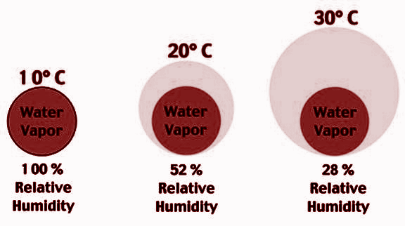
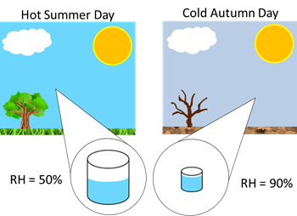
______________ air temperature = _________________ in relative humidity

Dew Point
Dew point is the temperature to which a parcel of ___________________________

_______________________to reach saturation.

Severe Weather
Wind: Air flows from areas of ____________pressure to areas of ___________pressure.

Low Pressure System vs. High Pressure System
 | Low | High
Air | Sinking | Rising
Pressure Behavior | Pressure drops = Cyclone | Pressure increases = Anticyclone
Wind Behavior | Winds blow _________________________ | Wind blows outward and ____________________
Weather Associated | __________________________ | _______________________
Symbol | “L” that is RED | “H” that is BLUE

L

H

Topic: Air Masses
Air mass is an immense body of air that is characterized by ___________________________________________ _____________________ at any given altitude
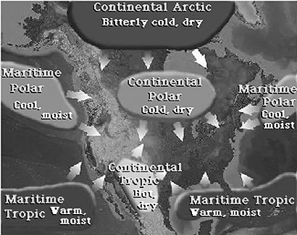

NAME  P – Polar | LOCATION  ___________Latitudes towards the poles | TEMPERATURE  ___________ Temps
T – Tropical | ________ Latitudes towards the equator | ____________ Temps
C – Continental | Over _______________ mass | Cold or warm, depending on the latitude
M – Maritime | Over _______________ | Cold or warm, depending on the latitude

Four Main Types of Air Masses
cP – Continental Polar  dry and cool  cold and dry in winter and summer | cT – Continental Tropical  dry and warm  hot, __________________ conditions
mT – Maritime Tropical  wet and warm  source of ________________________ in the United States | mP – Maritime Polar  wet and cold  mild, humid, _________________ cold air from Canada

Isobars: lines on a map that connect places of __________________________________
Closely spaced isobars: indicate a steep pressure gradient and _________________ winds.
Widely spaced isobars: indicate a weak pressure gradient and _________________ winds.

Topic: Air Fronts
 | Cold Front | Warm Front | Stationary Front | Occluded Front
Symbol
Profile/  Description | Cold air mass moves into an area ___________  ____________  ____________ air. | Warm air _____________  _____________  _____________ a cold, dense air mass | The ______________  ______________________________ of the front does not move | When an active cold front ________________ a warm front

