Unit 4 Review
- A tuning fork is used to produce sound waves with a frequency of 440Hz. The waves travel through the air at 344m/s. What is the wavelength of the wave?

- A student shakes the end of a rope with a frequency of 1.5Hz, causing a wavelength of 0.8m to travel along the rope. What is the velocity of the wave?

- An organ produces a musical note with a wavelength of 2.72m. What is the frequency of the note if the speed of sound is 348m/s?

- The diagram below shows a wave with four numbered parts. Which numbered part represents wavelength?

- The diagram below shows a wave trace. Distance Z is a measure of

- The figure below shows a spring with a wave traveling through it. Which type of wave is illustrated?

- A radio station transmits to a receiving antenna. What type of wave is this?

- Sound is transmitted via what type of wave

- Where does visible light fall on the electromagnetic spectrum?

- How are x-rays different from infrared waves?

- What type of electromagnetic radiation has a wavelength of 1x10⁻¹m?

- Which color of visible light has a wavelength of 5.8x10⁻⁷

- How are gamma rays different from radio waves?

- How do the wavelengths and frequencies of the EM spectrum change as you move across the spectrum from Radio Waves to Gamma Rays?

- What type of wave interference is shown below?
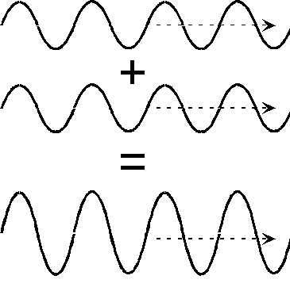

- The fact that sunlight can be separated into its different colors to form a rainbow is because of what property of light?
- What is the speed of light and what can change this number?

Unit 1 Review
- Two soccer players are playing ball. The table below shows the distance and direction of all the players kicks. Use the table to determine the distance and the displacement of the balls travel.
Kick | Distance and Direction
1 | 2m east
2 | 5m west
3 | 8m east
4 | 2m west

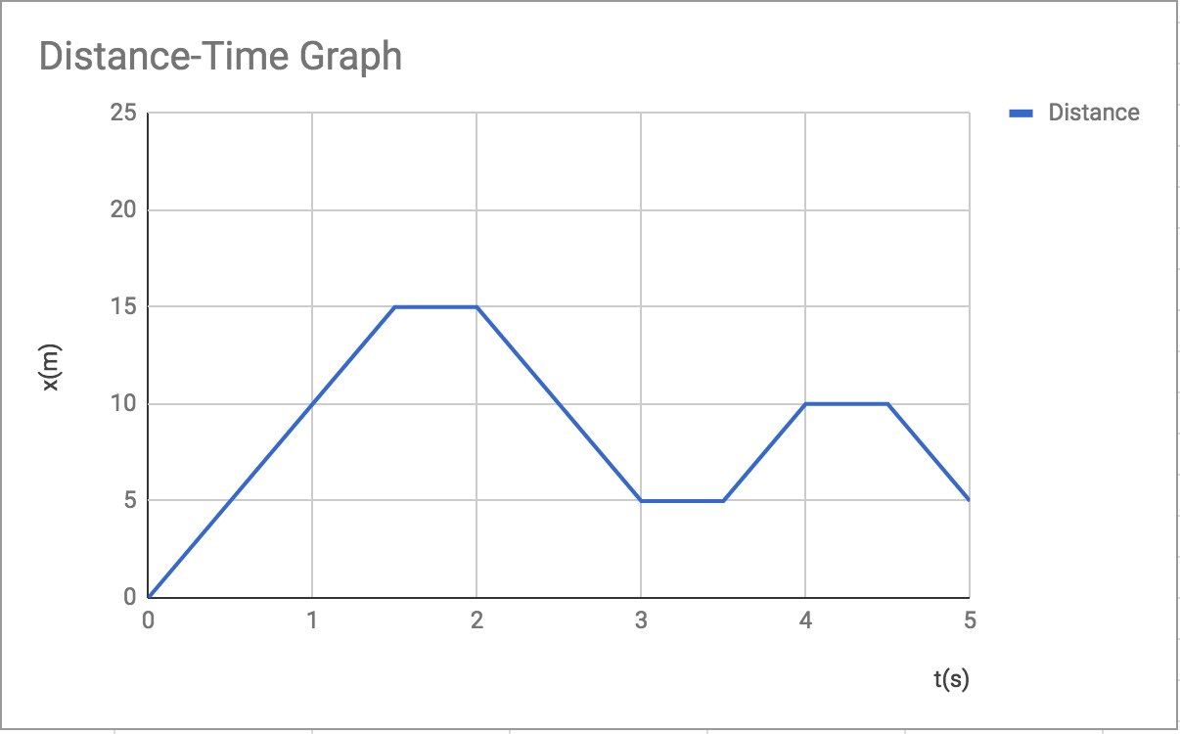
- What is the displacement of the object in the graph below?

- How far can a runner run if he runs at a speed of 0.9m/s for 120s?

- How much time is required for a bicycle to travel a distance of 100m at an average speed of 2m/s?

- An airplane takes off from Boston for the 980 km trip to Detroit. The plane lands two hours later. What was the plane's average speed for the flight in km/hr?

- What is the speed of the object represented by the graph above?

- How does the speed of the cart compare with t=6s and t=10s?

- The chart below represents the change in velocity for four different trains. If it took 5.38s to reach final velocity, which train had the greatest acceleration?

- A car’s velocity changes from 0 m/s to 40 m/s in 5 seconds. What is the average acceleration of the car?

Unit 2
- The object below is being pushed across the ground. The amount of force used to push the object is 4N and the amount of friction is 12N. What is the net force acting on the object below?
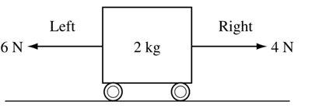
12N

- A 3kg box being pushed at an acceleration of 2m/s/s, how much force is being used to push the box?

- Which of Newton’s Laws explains why it takes more force to move a 500 kg object with the same acceleration of a 50kg object?

- Four boxes of varying mass were pushed across the floor with varying amounts of force. According to the table below, which have the greatest acceleration?

Box | Force (N) | Mass (kg)
1 | 20N | 5kg
2 | 10N | 10kg
3 | 15N | 5kg
4 | 25N | 5kg

- An object that weighs 10 N falls while encountering 10 N of air resistance. Which statement about the motion of the object is true?

10N
10N
- The diagram below shows a board on top of two bricks with a cylinder on top of the board. The board exerts a force of 50N up. Which best explains this situation? (Hint: list the forces and draw a force diagram for the cylinder)

- A bag of groceries has a mass of 10 kilograms. What is the weight of the bag?

- What is the mass of a pet turtle that weighs 10 N?

- What type of friction is caused when a ball rolls down a hill?

- What type of friction occurs when an eraser is rubbed across a piece of paper

- What type of friction keeps a heavy box in place as you try pushing it across the floor?

- What type of friction causes a skydiver to slow after opening his parachute?

- Calculate the momentum of a 15 kg ball that is moving toward home plate at a velocity of 60 m/s.

Unit 3 Review
- How much potential energy does a 120 kg person gain when she walks to the top of a 40m tall hill?

- The diagram below represents a divers motion from the top of a high diving board into a pool of water. At which labeled point does the dive have the least potential energy?

- An object has a mass of 12.8kg and a velocity of 8.4 m/s. What is the kinetic energy of the object.

- How much energy does a ball weighing 3N have if it is 50m above the ground?

- A ball with a mass of 5 kg is dropped from a resting position 10m above the ground. What is the potential energy of the ball just before it is dropped?

- A student moves a box across the floor by exerting 23.3N of force and doing 47.2J of work on the box. How far does the student move the box?

- You complete a task in 30s and your friend completes the same task in 60s. Who does the most work?

- How much work can be done in 9s if 28W of power are used?

- How much work is being done if you use a 24N force over a distance of 5m?

- How much power is produced if you do 78J of work in 58s?

- If 15N of force are applied to a cart to move it a distance of 5m, how much work is done on the cart?

