Forecasting Weather MAP Worksheet #1
Figures 1—4 are weather maps for a 24-hour period. The maps show the position of pressure systems and fronts in the United States every 12 hours, beginning at 12:00 A.M. on Thursday. Examine the maps and think about what is occurring. Then answer the following questions.
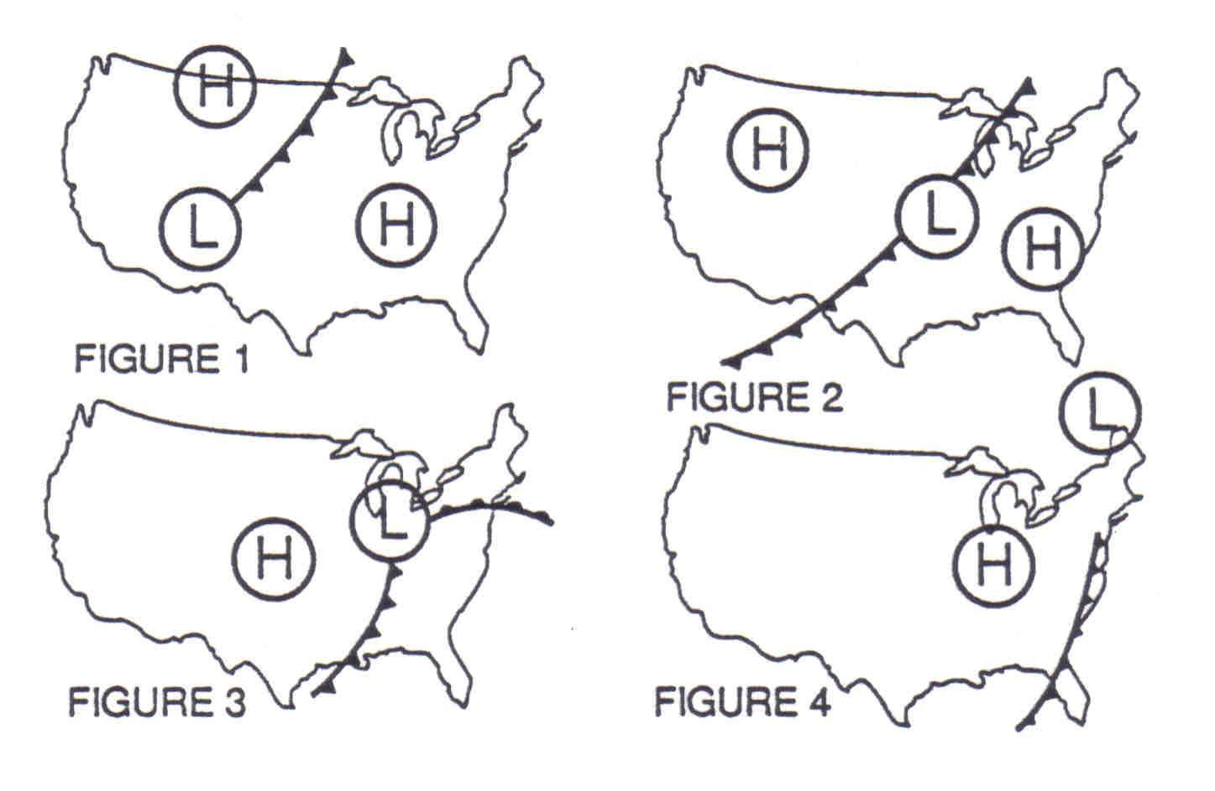

Forecasting Weather MAP Worksheet #2
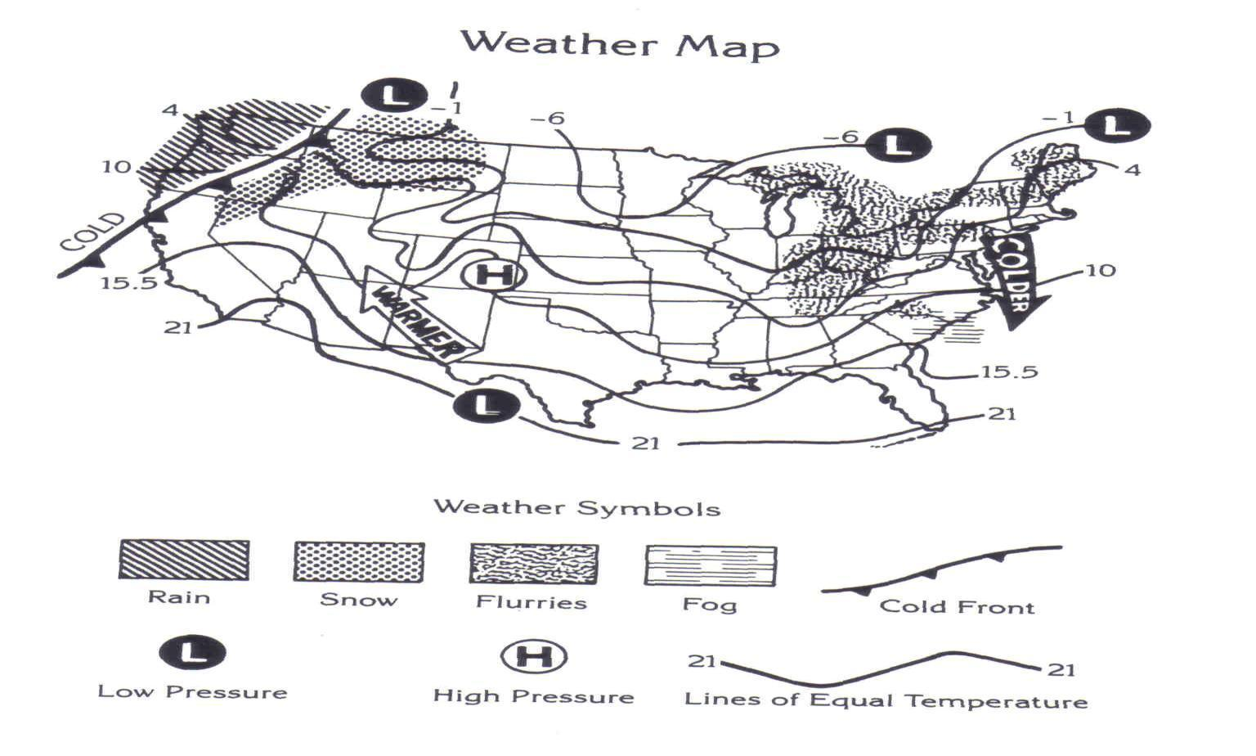

Forecasting Weather MAP Worksheet #3

Forecasting Weather MAP Worksheet #3

Forecasting Weather MAP Worksheet #3

Forecasting Weather MAP Worksheet #4

The symbols on the weather map below show the locations of fronts, high- and low-pressure areas, and different kinds of precipitation across the United States at 2:00 in the afternoon on a particular day in March. Shaded bands on the map indicate areas that have about the same temperature. The key below the map tells what the symbols mean.

