WAVE ANATOMY

#3

#2
#1

#4
#5
#2

Mechanical Waves – vibrate matter

Transverse - matter moves ___________________________ to direction the wave travels

Longitudinal (Compressional) - matter vibrates in_____________direction that wave travels

Surface – combination of transverse & longitudinal, producing circular motion
Ex. Earthquake or Ocean waves

Velocity of Sound Waves
- Sound must be transmitted through matter
- Velocity depends on _______________________
- v at 0͒ Celsius is 332 m/s, 344 m/s at 20͒ degrees C
- Travels faster through ________________air
- Faster through solids & liquids

Loudness and Pitch
- Intensity of sound depends on ______________________________
- Loudness describes a person’s __________________to intensity
- Measured in decibels - dB
- Pitch - Way a person hears frequency (Hertz)

WAVE ANATOMY

#3

#2
#1

#4
#5
#2

Mechanical Waves – vibrate matter

Transverse - matter moves ___________________________ to direction the wave travels

Longitudinal (Compressional) - matter vibrates in_____________direction that wave travels

Surface – combination of transverse & longitudinal, producing circular motion
Ex. Earthquake or Ocean waves

Velocity of Sound Waves
- Sound must be transmitted through matter
- Velocity depends on _______________________
- v at 0͒ Celsius is 332 m/s, 344 m/s at 20͒ degrees C
- Travels faster through ________________air
- Faster through solids & liquids

Loudness and Pitch
- Intensity of sound depends on ______________________________
- Loudness describes a person’s __________________to intensity
- Measured in decibels - dB
- Pitch - Way a person hears frequency (Hertz)

Wave Calculations
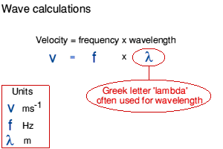
Rearranged Equations

Practice:
- A hummingbird beats its wings up and down with a frequency of 80.0 Hz. What is the period of the hummingbird's flaps?

- Radio station KSON in San Diego broadcasts at both 1240 kHz (AM) and 97.3 MHz (FM).
a) How long is each? (kilo = 1000 & mega = 106)

