Name_______________________________________ Multiple Choice (60) ______

Practice Test #3 Matching (36)
Physical Science Due: WEDNESDAY 12/12 Total ______

Multiple Choice (2 pts each)

1. Which of the following is NOT required to describe motion accurately?
A. frame of reference B. direction C. distance D. exact velocity

2. When two displacements represented by two vectors are in the same direction, what do we do with the two magnitudes?
A. add them B. subtract them C. divide the larger one by the smaller one D. multiply them

3. What type of speed does a car’s speedometer read?
A. car’s average speed B. car’s velocity C. car’s instantaneous speed

4. If a plane has traveled 4,980 miles in 5 hours, what is the average speed of the plane during its flight?
A. 950 m/hr B. 996 m/hr C. 24,900 m/hr D. 0.001 m/hr

5. Which line on the time versus distance graph below has the fastest speed?
A. line A B. line B C. line C D. line D

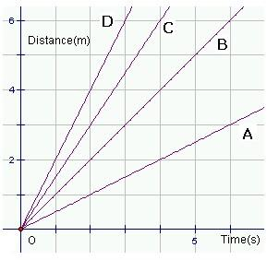

6. What two factors does the term “velocity” describe?
A. speed & distance B. distance & direction C. speed & direction D. acceleration & direction

7. What term do we use to describe the rate at which velocity changes?
A. instantaneous speed B. acceleration C. average velocity D. average speed

8. When the acceleration of an object is a negative number, what is happening to the speed of the object?
A. it is increasing B. it is decreasing C. it is staying the same
9. What is the force pulling down on an object in free fall?
A. gravity B. wind resistance C. terminal velocity D. friction

10. The 2002 Lingenfelter Chevrolet Corvette can accelerate from 0 m/s to 26.8 m/s in 1.97 s. What is its acceleration?
A. 136.04 m/s² B. 13.60 m/s² C. 0.73 m/s² D. 52.79 m/s²

11. If there were no air resistance, would an elephant and a mouse fall at the same speed?
A. yes B. no

12. What is the acceleration rate due to gravity?
A. 8.9 m/s² B. 9.8 m/s² C. different for different objects D. I do not know

13. What force slows objects in free fall down on Earth because of the atmosphere?
A. gravity B. air resistance C. currents D. wind

14. Which of the two time versus distance graphs below shows acceleration?
A. graph A B. graph B

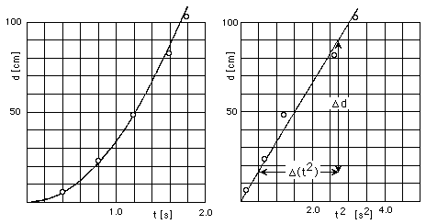

Graph A Graph B

15. What do we call a push or a pull that acts on an object?
A gravity B. force C. Newton D. vector

16. When all of the forces acting on an object are balanced, is there any change in an object’s motion?
A. yes B. no C. can’t tell without more information

17. What force acts on all moving objects on Earth?
A. friction B. gravity C. air resistance D. all of the above

18. Which of the following is NOT a correct association?
A. static friction; objects at rest
B. sliding friction; object sliding on a surface
C. rolling friction; 100 to 1000 larger than sliding friction
D. fluid friction; objects moving in a fluid

19. Which of the following does NOT cause an increase in gravity?
A. increase in mass B. decrease in distance between objects
C. increase in distance between objects

20. What term do we use to describe the fastest speed at which a falling object can fall once gravity is balanced with air resistance?
A. initial velocity B. final velocity C. terminal velocity

21. Do projectile objects take longer to fall to Earth than dropped objects?
A. yes B. no C. cannot tell without more information

22. What scientist described three laws of motion and proved the existence of gravity?
A. Aristotle B. Galileo C. Newton

23 Which of the following is NOT a correct association?
A. 1st Law of Motion; object at rest stays at rest, object in motion stays in motion unless acted on by an outside force
B. 2nd Law of Motion; for every action there is an equal & opposite reaction
C. 3rd Law of Motion; for every action there is an equal & opposite reaction
D. 2nd Law of Motion; force = mass x acceleration

24. What force is acting on your mass to determine your weight?
A. air resistance B. gravity C. inertia D. momentum

25. What happens to the distance it takes to stop for an object with greater momentum?
A. it decreases B. it increases C. it stays the same

26. Which of the following cannot be created nor destroyed?
A. matter B. energy C. momentum D. all of the above

27. What is the force required to accelerate a 56 kg object by 15 m/s²?
A. 840 N B. 3.73 N C. 0.27 N

28. If a person has a mass of 330 kg, how much do they weigh?
A. 3234 N B. 33.67 N C. 0.29 N

29. What is the momentum of a roller coaster car that has a mass of 350 kg and a velocity of 2.5 m/s?
A. 875 kg · m/s B. 140 kg · m/s C. 0.007 kg · m/s

30. If a semi-truck has a momentum of 482,400 kg · m/s and an velocity of 26.8 m/s, what is its mass?
A. 1,2928,320 kg B. 18,000 kg C. 5.55 kg

Matching (2 pts each)

_____31. distance A. describes a decrease in the speed of an object

_____ 32. displacement B. SI unit is Newtons (kg ·m/s²)

_____ 33. vector C. represents acceleration on a time versus distance graph

_____ 34. speed D. force that opposes the motion of an object through a fluid

_____ 35. straight slope E. direction & length from starting to ending point

_____ 36. deceleration F. attractive force that acts between any two masses

_____ 37. acceleration G. friction force that acts on rolling objects

_____ 38. weightlessness H. SI unit is meters per second (m/s)

_____ 39. curved slope I. resistance of motion

_____ 40. force J. the tendency of an object to resist a change in its motion

_____ 41. rolling friction K. the length of a path between two points

_____ 42. fluid friction L. how much material is present

_____ 43. gravity M. represents constant speed on distance versus time graph

_____ 44. Friction N. SI unit is kg ·m/s

_____ 45. inertia O. sensation produced when an object and its surroundings are in
free fall
_____ 46. weight P. a quantity that has magnitude and direction

_____ 47. momentum Q. the force of gravity acting on an object

_____ 48. mass R. SI unit is meters per second squared (m/s²)

