Topic: Mechanical and Chemical Weathering
Weathering: the breaking _______________________________________________________near Earth’s surface
Mechanical Weathering | Chemical Weathering
- When ___________________________ break rock into smaller pieces  - Does_____ change the rock’s____________  - Frost Wedging  - Water enters cracks and crevices in rocks  - Water _____________________________the cracks  Examples:  - Unloading  - The ______________________________________ of rocks overlying igneous rocks  - Exfoliation: slabs of outer rock ___________________________ loose  Examples:  - Biological Activity  - _______________________________  Examples: | - The transfer of rock into _____________________________ new compounds  - Agents of Chemical Weathering  - Water  Examples:  - Oxygen  Examples:  - Carbon Dioxide  Examples:  - Spheroidal Weathering  Examples:
Topic: Erosion & Mass Movements
What is Erosion?
Removal and_______________________________________________ from one location to another

Agents of Erosion

Agents of Erosion

Deposition:
- Materials are ____________________ in another location
- Final stage of erosion

How does wind erode soil?

- ____________________________________________________________________
- Sand Dunes
  - Mounds or ridges of sand
  - Wind also can cause them to move

How do humans control erosion?
- Planting __________________________________________ called windbreakers
- _________________________________________ hillsides
- _________________________________________ the contours of hills
- Rotating crops

Weathering
Erosion

Soil
Part of the __________________that ______________________ the growth of plants
Regolith
Layer of rock and _______________________________________________ that cover most of Earth’s land surface

Soil Formation
Weathering of ______________ that is carried away (Think rock cycle)

Soil Formation Factors
- Parent Material
  - ________________________ of the mineral matter in the soil
- Time
  - Important in all geologic processes
  - The________________________ a soil has been forming, the _________________ it will become
- Climate
  - _________________________________________ on soil formation
  - Influences of temperature and __________________________ affect rate, depth and type of weathering
- Organisms
  - _______________________ organic matter in soil
- Slope
  - ____________ slopes often have __________________ developed soils

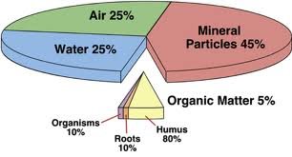
Soil Composition:
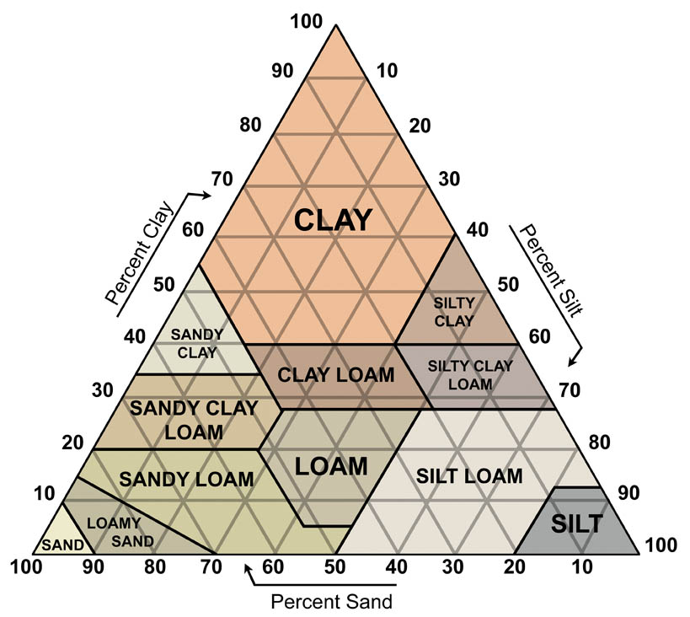
45% _________________________
25% ____________________________
25% _________________________
5% ________________________
Decayed remains of organisms

Soil Texture
- Sand (large size)
- Silt (feels like flour)
- Clay (small size)
- Loam (mix of all three; best for plants)

Mass Movements
Mass Movement
- The transfer of rock and soil _____________________________________due to gravity
- Classified by

Mass Movement Types:

Why mass movements are more frequent?

- ____________________________________
- Droughts
- Less vegetation
- Increased storms

Human Prevention of Mass Movements:
- Increasing soil stability:

  - ___________________________ vegetation
  - __________________________ (maintaining) the landscape
  - Effective _________________________

Chemical
Weathering
Physical
Weathering

