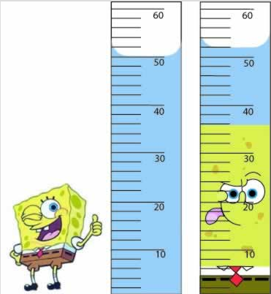
Unit 5 - QUICK REVIEW
- Describe in at least 40 words how you would determine the density of spongebob using the tools below.

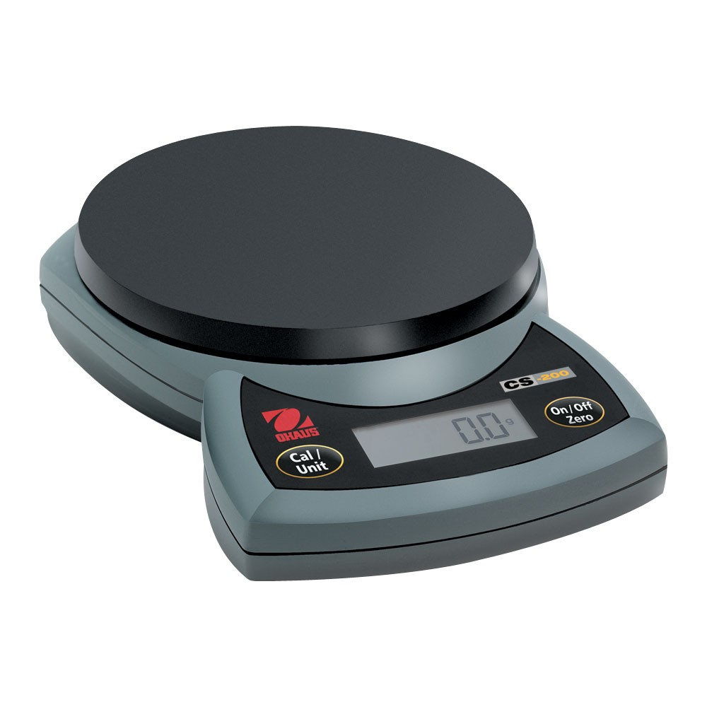

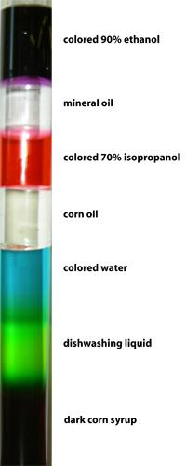
- The mass of spongebob is 6g. What is the spongebobs density?
- Describe two ways in which density can be used.
- The graduated cylinder to the right contains several different materials. Describe what caused these materials to become layered.
- Use the equation for density to calculate the following.
  - If the mass of an object is 2.4g and the volume is 8.5mL what is it’s density?
  - If the density of an object is 2g/mL and the mass is 5g what is its volume?
- Use the graph below to determine the density.
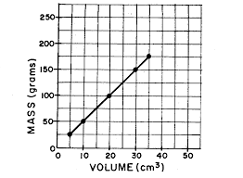

Unit 5 - QUICK REVIEW
- Describe in at least 40 words how you would determine the density of spongebob using the tools below.

- The mass of spongebob is 6g. What is the spongebobs density?
- Describe two ways in which density can be used.
- The graduated cylinder to the right contains several different materials. Describe what caused these materials to become layered.
- Use the equation for density to calculate the following.
  - If the mass of an object is 2.4g and the volume is 8.5mL what is it’s density?
  - If the density of an object is 2g/mL and the mass is 5g what is its volume?
6. Use the graph below to determine the density.

- Compare a physical change to a chemical change in at least 25 words.
- Define the term malleability.
- Describe the difference between compounds and mixtures in at least 25 words.
- Label each of the pictures below as solids, liquids, or gases. Then tell if the picture represents a pure substance or a mixture.
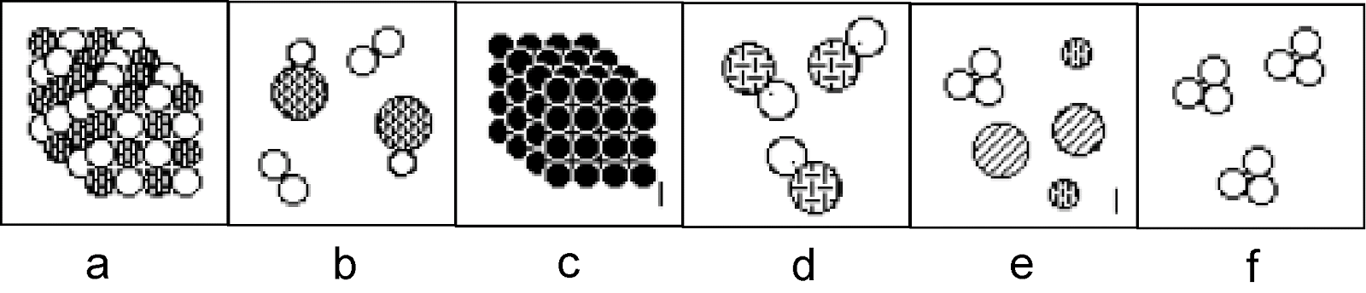
- Tell if the following is a pure substance or a mixture
  - Sand and water
  - Sweet tea
  - gold
  - Fruit Jello
  - Pond water
  - Distilled water
  - Methane (CH₄)
  - Milk
  - Fog
  - Bronze statue
  - Dirt
  - Cheese
  - Carbon Dioxide (CO₂)
- For each question in number 11 that you labeled a mixture go back and label them as heterogeneous or homogeneous.
- For each question in number 11 that you labeled as a pure substance go back and label as an element or a compound.

7. Compare a physical change to a chemical change in at least 25 words.
8. Define the term malleability.
9. Describe the difference between compounds and mixtures in at least 25 words.
10.Label each of the pictures below as solids, liquids, or gases. Then tell if the picture represents a pure substance or a mixture.
11. Tell if the following is a pure substance or a mixture
  - Sand and water
  - Sweet tea
  - gold
  - Fruit Jello
  - Pond water
  - Distilled water
  - Methane (CH₄)
  - Milk
  - Fog
  - Bronze statue
  - Dirt
  - Cheese
  - Carbon Dioxide (CO₂)
12. For each question in number 11 that you labeled a mixture go back and label them as heterogeneous or homogeneous.
13. For each question in number 11 that you labeled as a pure substance go back and label as an element or a compound.

