Unit 7 - Water Quality
Monday - November 26th
Water Pollution Brainstorm

Type of Pollutant | Examples of Pollutant
Sediments
Oxygen Demanding Agents
Toxic Metals
Inorganic Plant Nutrients
Organic Chemicals

Non-Point Source
Start:

End:

Examples:
Point Source

Start:

End:

Examples:

Vocabulary Term | Definition
Water Pollution
Pollutant
Sediments
Activity #1 - Newslea - Pollutants - Microplastics
As you read the article, fill in the table below. Explain how each pollutant is a nuisance for water quality.
Type of Pollutant | Description of impact on the environment and organisms
Tires
Synthetic Clothing
Tennis Balls
Laundry And Dishwasher Pods/Tablets
Cigarette Butts
Glitter
Wet Wipes
Tea Bags
Paint
Takeaway Cups
November 27th - Bioaccumulation and BOD
BOD: Oxygen is removed from water by bacteria
Result - Less available oxygen for organisms other than bacteria
Where to find BOD at its highest? WHY?
All streams have some ability to breakdown organic waste. Problems occur when a stream is overloaded with ______________________________________.
Low Pollution:
Low BOD
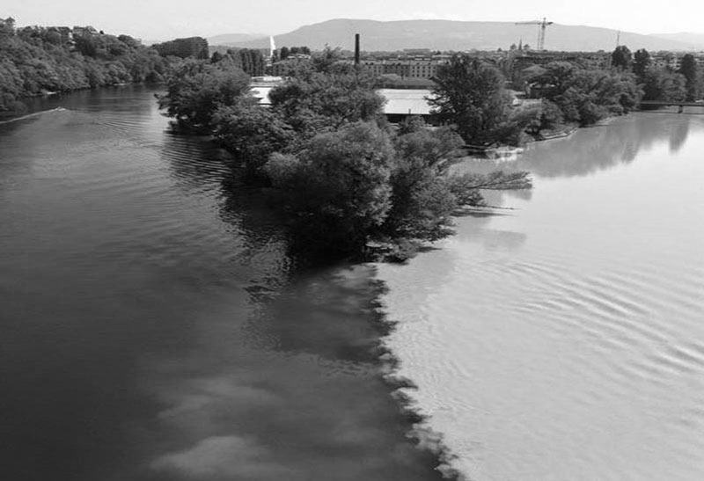
High Dissolved Oxygen
High Pollution:
High BOD
Low Dissolved Oxygen

Biological Oxygen Demand Graphing Activity
Part A: Data Table: Use the information in the data table to create a BOD vs. DO graph below

Biological Oxygen Demand | 15 ppm | 30 ppm | 60 ppm | 72 ppm | 98 ppm | 115 ppm | 125 ppm
Dissolved Oxygen | 100 ppm | 80 ppm | 60 ppm | 40 ppm | 12 ppm | 5 ppm | 0 ppm

Graph Title ________________________________________________________
Biological Oxygen Demand (ppm)
15 30 45 60 75 90 105 120 135 150
15 30 45 60 75 90 105 120
Dissolved Oxygen ( ppm)

Part B: Drawing Conclusions from the Graph:
Using the graph you created, make three specific statements about Biological Oxygen Demand (BOD) and Dissolved Oxygen (DO). A possible sentence frame - The graph above shows ______________ about BOD and ___________________ about DO.
Part C: Conclusion Questions
- What does the word biological mean?

- What does the word demand mean?

- Compare and contrast oxygen demand vs. dissolved oxygen content.

- Explain how oxygen demand and dissolved oxygen content can be used to determine the health of the water source. (Does high or low oxygen demand mean healthy water, explain!)

- In 3-5 sentences, explain the importance of the health of a water source to not only organisms who live there, but the human who use that water for their daily uses.

Bioaccumulation:
Toxic metals that can be absorbed by plants or animal tissues
Bioaccumulation: toxins increase in amounts as you move up the trophic levels.
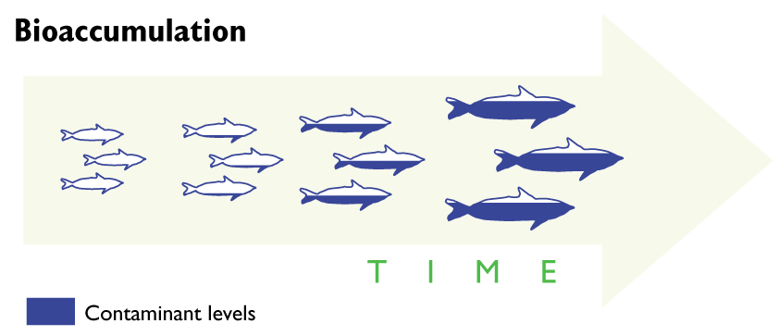

Vocabulary Term | Definition
Biological oxygen demand (BOD)
Photosynthesis
Bioaccumulation
Eutrophication
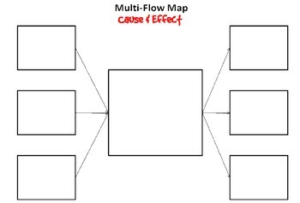
#1 Increasing plastics into waterways
#1 =>Effect
#2 Decreasing sediments into a lake
#3 Removing plants from a stream
#2 => Effect
#3 => Effect
Water Pollution

November 28th - Macroinvertebrates
Video Conclusions:

Stream Macroinvertebrate Sampling Simulation
Procedure:
- Remove your organisms from the baggie and place them face up on the table.
- Use the stream Sampling Classification Sheet to record the types of organisms that are present.
- Write the organisms under their appropriate group number on the sampling worksheet (on the back).
- Count the number of organisms in each group and place BEFORE the multiplication sign in Column C
- Do the math in Column C for each group and place the answer in Column D
- Add up all the sums in Column D to obtain your biotic index number.

Post-Lab Questions: Should be done using complete sentences.
- Which group number had the most organisms present (use Column B)?

- The following chart should be used to determine the Biotic Index of your water quality.
Greater than 22 | Excellent
22-17 | Good
16-11 | Fair
Less than 11 | Poor
Use the chart to determine the quality of your water and discuss why your water quality was that way.

- What are three factors that affect water quality (use Background information to help)?

- What steps could be taken to improve water quality of a body of water?

Vocabulary Term | Definition
Bioindicators
Biotic Index
Macroinvertebrate

November 29th - Laws and Treatment
Drinking water (Potable Water) is purified by

Water Treatment Stages:
1. Screening
2. Aeration
3. pH correction
4. Flocculation
5. Sedimentation
6. Pre-chlorination
7. Filtration
8. Disinfection
9. pH adjustment
Municipal water Purification Plant
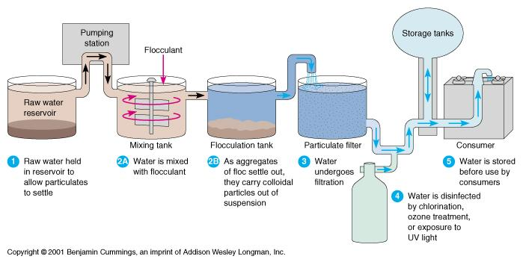
Home Septic System
- No Chlorine used
- Uses a settling tank to settle the solids
- Lets waste water percolate into the soil to decompose

Glencoe - Virtual Labs
Using this site: http://www.glencoe.com/sites/common_assets/science/virtual_labs/CT04/CT04.html
Directions:
- Test all the water samples by scrolling through the different water types and hit “Test”
- As you test the samples, fill in the table below, to complete the Type of Contamination and Treatment, use the tabs at the bottom of your screen
- Use the information you collected to answer the discussion questions at the end.
Sample Name | City | Mountain | Lake | Well | Rural
Acidity pH
Metals (mg/L)
Coliform Bacteria (ml)
Pesticides (mg/L)
Nitrates
Type of Contamination
Treatment

Discussion Questions:
- What contaminants were found in surface water samples? What contaminants were found in groundwater samples?

- Why might groundwater and surface water have different contaminants? Explain beyond their different locations.

- Generally farmers do not farm and industries do not build factories on the side of mountains, making the mountain sparse of human population. Develop a hypothesis to why there might be high levels of nitrate in the water?

- Explain the concept of pH and what chemicals are used to treat low pH levels?

- Water in an old building was tested recently for metal contaminants and it showed high copper and iron contents with low pH levels. Twenty years ago, a water reading from this same exact building had low pH levels, but no metal contaminants. How and why did this occur?

Vocabulary Term | Definition
Clean Water Act
Home Septic Systems
Water Treatment System

November 30th - Deprivation and Conservation
Observation Lab:
Directions:
- Using the microscope, look at the pond water displayed by the lens
- Using the microscope, look at the tap water displayed by the lens
- Using the microscope, look at the purified water displayed by the lens
- For each water type, fill in the table below and answer the questions afterwards

Data Table:

Water Type | Description of Color | Organisms Present? | pH level | Possible Treatment Needed
Pond Water
Tap water
Purified Water

- Based on just your observations, which water do you think is the cleanest and why?

- Based on your data, which water is the cleanest and why?

- Explain why you picked the treatment plans you did.

- Why is it important to reduce how many chemicals are in our treatment processes? (Think about point and non-point sources)

Vocabulary Term | Definition
Water Conservation
Water Deprivation
Compost

