Unit 9 Guided Notes

Climate: ________________________________________________________over an area
Greenhouse Gases:
- These are gases that allow for our _________________________________________ to be suitable to live

- The gases include: _______________________, Carbon dioxide, _______________________________ and Nitrogen

Human Impact on Greenhouse Gases Brainstorm:

Koppen Classification System ---THINK AIR MASS LOCATIONS
Uses mean monthly and annual values of ____________________________________________ and ____________________
Group | Description
Humid Tropical | _____________ temperatures year round and for their large amount of year round _____________
Humid Mid-Latitude | land/water differences play a large part. These climates have _________________________ summers and __________________________________winters.
Dry | _________________ rain and a huge daily temperature _________ ( ____________________________ )
Highland | Total precipitation is ___________________and seasonal temperatures ____________________________.
Polar | These climates are part of areas where ____________________________ ice

Group | Example Locations
Humid Tropical
Humid Mid-Latitude
Dry
Highland
Polar

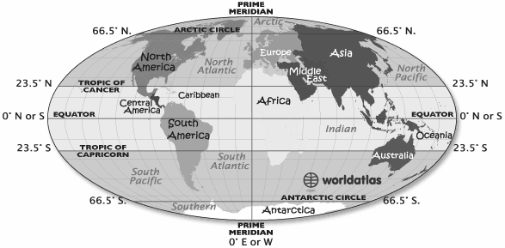

Factors that Affect Climate:
- Latitude
As latitude ____________________, the intensity of solar energy ________________
Three Zones:
Tropical:
Temperate:
Polar:
- Elevation
Higher the elevation is, the _________________________________the climate

Elevation determines amount of ____________________________________ it receives

- Topography
Land features affect amount of precipitation that falls over an area
Mountains cause a rain shadow event
One side has _______________________________
One side has _________________________________

- Water Bodies
Temperature of the water body _________________________________________ of the air above.

- Global Winds
Winds distribute heat and moisture around the Earth
Warm air moves to the _________________________
Cold air moves to the_________________________
- Vegetation --Affects both temperature and precipitation
Temperature
Influence how much of the sun’s energy is _____________________________and how quickly it is________________
Precipitation
When plants release water vapor from its ______________________________
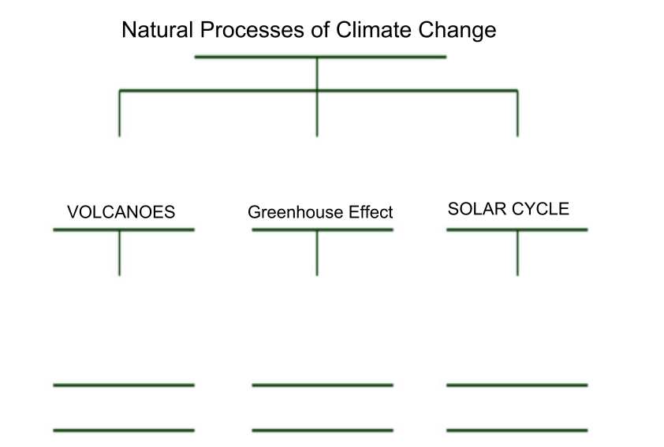

Climographs:
Definition: what scientists create to show a particular location's __________________________________________ and ____________________________________ during the year

How to read a Climographs:
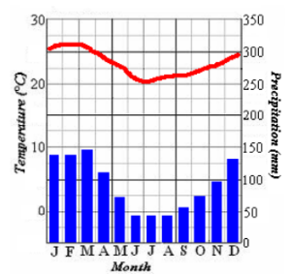

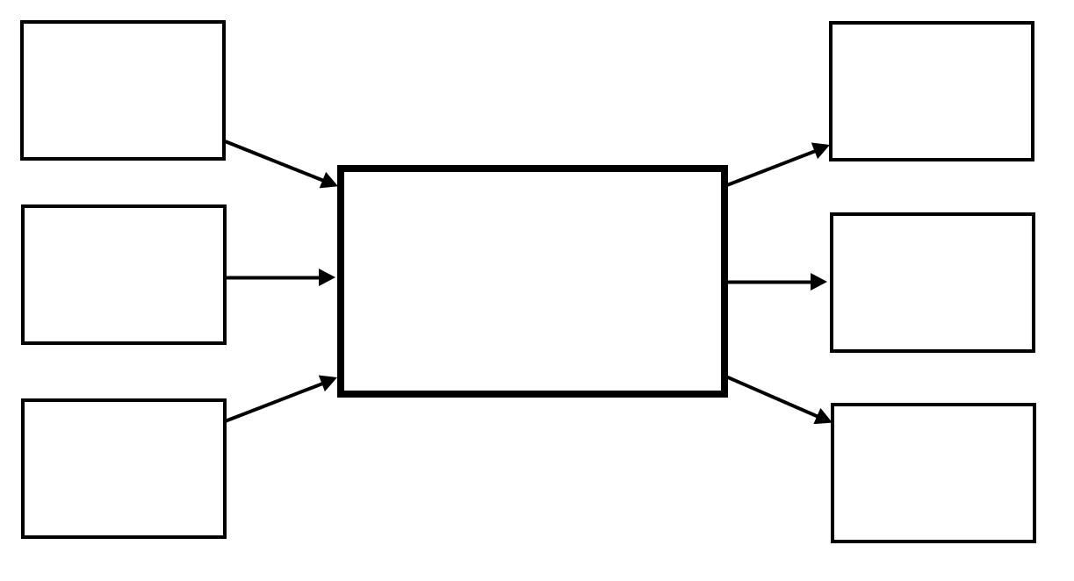
CLIMATE CHANGE
CO2 Fluctuations
- Changes in _____________________________________________ rates

Carbon Sinks
- CO2 is absorbed by the __________________and forms carbonic acid.
  - Decrease in the ocean’s pH levels in the ocean.
  - Coral Reefs: High levels of CO2 negatively affects corals photosynthesis
  - 50% of coral reefs have been destroyed
  - Ocean Acidification
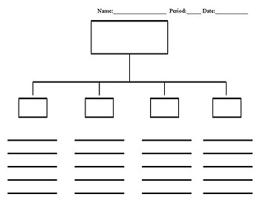
EFFECTS OF CLIMATE CHANGE FROM HUMAN IMPACT

